A

Mini Project Review

On

**Fastest Finger First Using J-K Flip Flop**

**For the Course**

**“Digital Electronics”**

Date: 29.9.2021

**Submitted By,**

**K.Sridhaar**

**P.Karthick Selvan**

Abstract

**Fasted Finger First is an important circuit which is commonly used in quizzes, games and other multi-player activities. In quiz events, the circuit is generally used in rapid fire rounds where it has to be determined that which participant has first responded to the question. It is necessary to use such circuit in a quiz as many times, there is a minor difference between the responses of participants. In such cases, it becomes difficult by a human observer to determine which participant has responded first to the query.**

**In this project, a simple electronic circuit for fastest finger first has been designed.**

Description

**The circuit is based on JK Flip-Flops. The Flip-flop is a digital electronic circuit with two stable states that can be used to store binary data (0 or 1). The JK Flip-Flop is used here as it is the most versatile flip-flop. For JK Flip-Flop, 7473 IC is used in this project. The 7473 IC is a dual J-K flip flop IC.**

**This circuit has been designed for four-player quiz. Each player has a button which has to be pressed for response. There are seven segment displays interfaced in the circuit as such that there is a seven segment display for each player. Each player is assigned a number. The seven segment corresponding to the player who responded first displays the assigned number on response. At the same time, an LED glows to indicate the response.**

Components Required

* **7473 Dual J-K Flip Flop IC**
* **Push Button**
* **IN4748-Diode**
* **10K Resistors**
* **1K Resistors**
* **330 ohm Resistors**
* **BC547 Transistors**
* **LED**
* **7 Segment Common Cathode**

**Block Diagram**

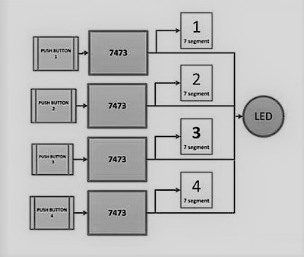

**Block Diagram of 7473 JK Flip Flop IC based Fastest Finger First Circuit**

Circuit Diagram

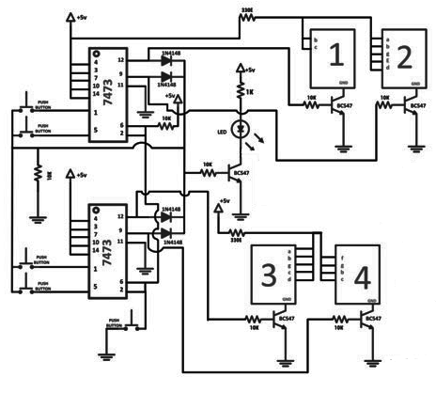

**Circuit Diagram of 7473 JK Flip Flop IC based Fastest Finger First Circuit**

Working

**The working of this circuit is based on a feedback technique applied to JK Flip-Flops. There is a feedback provided between outputs of the JK Flip-Flops and one terminal of the push buttons. The output of the Flip-Flops is connected to respective anode of**[**diodes**](https://www.engineersgarage.com/tutorials/diodes)**. All the diodes are shorted at their cathode terminals. The output of the shorted diodes is used as clock of the flip-flops at common node of the push buttons.**

**Initially, when no participant has pressed any switch, the output of the JK Flip-Flops stays LOW and so the output of the diodes also stays LOW. When any participant presses her push button, a LOW signal is supplied to the clock input of the respective JK Flip-Flop. This LOW input appears as a negative edge of a pulse. So, the output toggles from LOW to HIGH of the respective JK Flip-Flop.**

**As the feedback is provided using shorted diodes, even if one of the outputs is HIGH, the feedback signal also sets to logic HIGH. So, the common node of the push buttons is set to logic HIGH. Now, even if, another participant operates the push button, the clock input would remain HIGH but not a negative edge. So, only the output corresponding to the participant, which operated first, will stay HIGH.**

**Before going to the next event/question, the outputs of all the JK Flip-Flops must be LOW. For this purpose, a RESET button is connected with all the Flip Flops, which clears the outputs of all the Flip Flops. By clearing the outputs through RESET signal, the output of diodes are set to LOW i.e. the feedback signal is again revered to LOW. So, the circuit returns to the initial state.**

**The circuit operates even in the tie situations i.e. when more than one participant operates their respective buttons at the same instant. This is possible because of the feedback technique. As the required clock signal is LOW, the inputs are acceptable until the feedback is LOW. At this LOW situation, all the flip flop outputs can be turned HIGH by operating the push buttons at a time. But, if at least one of the outputs is HIGH, the feedback becomes HIGH and further inputs are not acceptable. This feature makes the circuit flawless.**

**The output of JK Flip-Flops is connected to seven-segment displays. The maximum output current that can be supplied by the flip flop output pins is around 10mA or even less depending on the exact part number. So, the seven segments cannot be connected directly to the output of the JK Flip-Flops. In order to amplify output current from JK Flip-Flops, either BJT (**[**BC547**](https://www.engineersgarage.com/electronic-components/transistor-bc547-datasheet)**,**[**2N2222**](https://www.engineersgarage.com/electronic-components/2n2222-transistor)**etc) or MOSFET (2N7000, 2N7002 etc) need to be used. A transistor (BJT or MOSFET) is also required as the same current is used to drive LED and as trigger input to 555 IC operating in mono stable mode. The seven segments also must be connected in the circuit via a resistor of 330 ohms.**

**Here, four single digit 7-segment displays are connected such that each display shows a fixed number. The first 7-segment display is wired to show number 1, second 7-segment display is wired to show number 2 and so on.  The respective display is enabled by using the output of its JK Flip-Flop.**

Advantages

* **In Expensive.**
* **J-K Flip Flop used here is the most versatile.**
* **Can be increased to n players.**

Applications

* **This circuit can be used at quiz competitions at Schools and Colleges.**
* **This circuit can also be used in auction.**
* **This circuit can be used in TV Reality Shows and other game shows.**

************